**Web Page Report**

University Management

System

Subject Code: CSE-326

Group Project

|  |  |  |
| --- | --- | --- |
| Reg. No. | Name | Roll No. |
| 12310605 | Harsh Kamboj | 10 |
| 12322763 | Ananda Krishna SD | 26 |
| 12323071 | Rajverdhan Singh | 46 |

**Introduction**

Purpose

The primary objective of this report is to provide an exhaustive documentation of the University Management System web page's development and the extensive array of features it encompasses. This web page plays a pivotal role as the central interface through which students and faculty can seamlessly access and efficiently manage a wide spectrum of university-related functionalities. Its significance lies in its ability to streamline and simplify access to essential academic and administrative information, making it an indispensable tool for all members of the university community.

The University Management System web page represents a dynamic and user-centric approach to addressing the diverse needs of students and faculty. It serves as a one-stop platform for retrieving crucial data, such as student records, class schedules, examination-related details, pertinent announcements, and real-time updates on faculty availability.

By embracing this web-based solution, users can leverage the power of modern technology to enhance their academic experience and streamline administrative tasks. The combination of user-friendly design and functionality is made possible through the adept utilization of HTML and CSS, ensuring an aesthetically pleasing and structured interface that resonates with users.

As this project continues to evolve, it holds the promise of further enriching the user experience by introducing new features and addressing emerging needs. This report offers a comprehensive overview of the web page's journey, its pivotal features, and its role in the university ecosystem, providing a glimpse into its ongoing development and future potential.

Project Scope

The University Management System web page serves as an exceptionally user-friendly platform meticulously designed to facilitate the effortless access of crucial information for both students and faculty. This web-based system consists of two primary components: a user login page and a comprehensive main dashboard.

The journey commences at the login page, where users securely input their credentials to gain access. Upon successful authentication, users are welcomed into the main dashboard, a rich and multi-functional hub of essential information. Within this dashboard, users can access a wide range of indispensable data, including comprehensive student profiles, class timetables, detailed examination information, critical announcements, and real-time updates regarding the availability of teachers.

This remarkable web page was meticulously crafted utilizing the HTML and CSS technologies, ensuring a visually appealing and exceptionally structured interface. The harmonious amalgamation of these technologies empowers users with an instinctive and highly efficient user experience, greatly enhancing the management of university-related tasks and data. As this project advances, it holds the potential for further refinements and enhancements that will continue to enrich the overall experience for the university community. This report provides a comprehensive overview of the web page's fundamental components and functionalities, offering a glimpse into its promising future.

**Login Page**

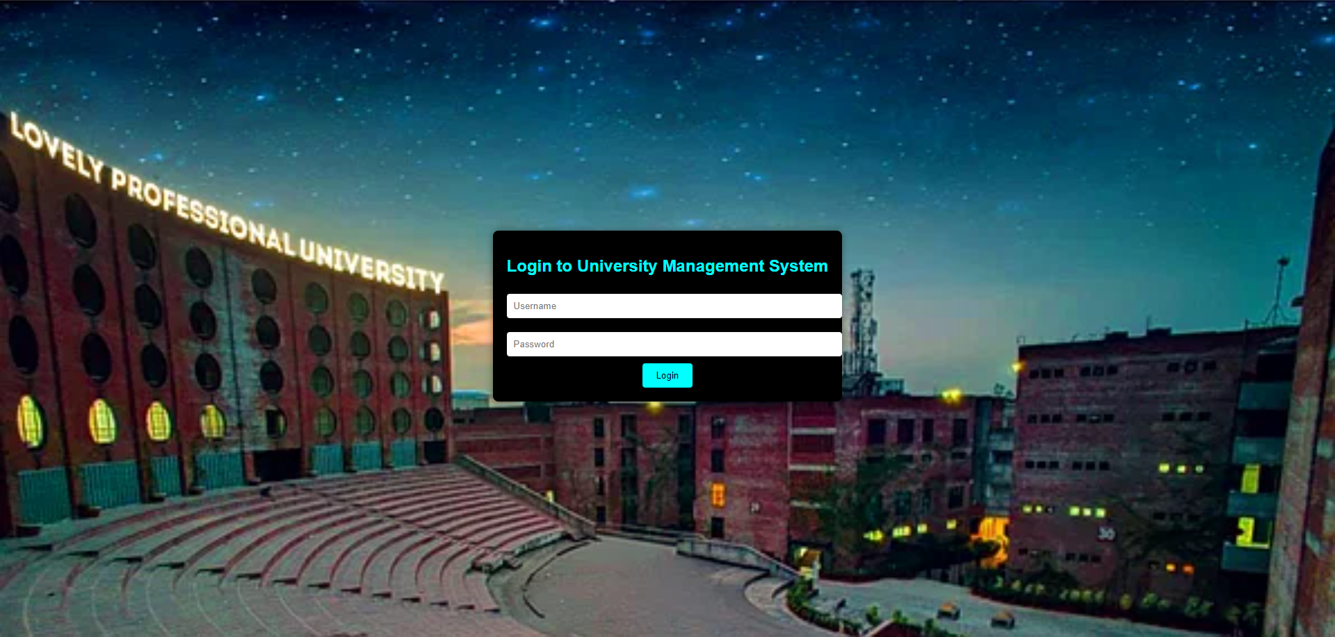

The login page is the entry point for users to access the University Management System. It includes the following key components:

**Background:** A visually appealing background image of the university campus.

**Form**: The login form where users can enter their credentials.

- Username field

- Password field

**Submit Button**: A "Login" button for submitting the login credentials.

**Main Dashboard**

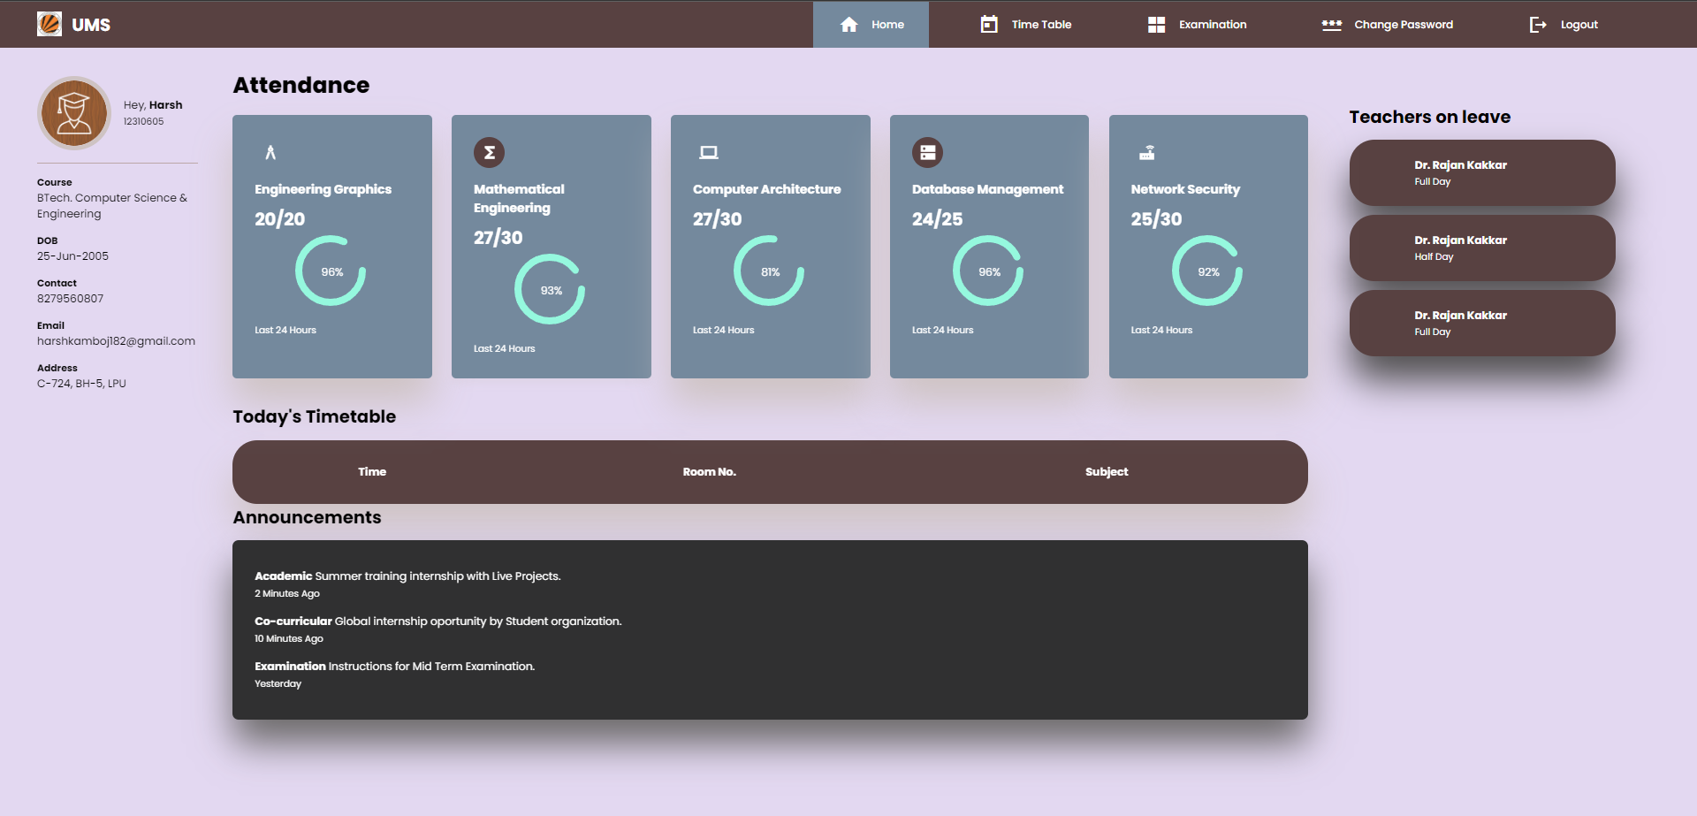

The main dashboard is the central hub for users after successfully logging in. It features the following elements:

Navigation Bar

The navigation bar provides quick access to essential functionalities. It includes the following options:

**Home**: The landing page of the system.

**Change Password**: Allows users to change their passwords.

**View Timetable**: Provides access to the class schedule.

**Examination**: Displays information about upcoming exams.

**Log Out**: A feature for securely logging out of the system.

Student Information

The dashboard provides information about the student, including their name, course, date of birth, contact information, email, and address.

Attendance

A section showing the student's attendance in various subjects. It includes the subject name, the number of classes attended, and a visual representation of attendance percentage.

Timetable

The timetable section displays the student's class schedule for the day. It allows users to navigate through different days' schedules.

Announcements

The announcements section provides important updates and news relevant to the university. It includes messages with categories such as academic, co-curricular, and examination.

Teachers on Leave

This section displays information about teachers who are on leave. It includes the teacher's name and the duration of their leave (full day or half day).

**Technologies Used**

The primary technologies used in the development of this web page are:

**HTML**: Used for structuring the web page and creating content.

For login page

<!DOCTYPE html>

<html lang="en">

<head>

    <meta charset="UTF-8">

    <meta name="viewport" content="width=device-width, initial-scale=1.0">

    <title>University Management System</title>

    <style>

        body {

            background-image: url("https://spiderimg.amarujala.com/assets/images/2020/04/29/750x506/lpu_1588148335.png");

            background-repeat: no-repeat, repeat;

            background-size: cover;

            font-family: Arial, sans-serif;

            margin: 0;

            padding: 0;

            display: flex;

            justify-content: center;

            align-items: center;

            height: 100vh;

        }

        .login-container {

            background: black;

            color: cyan;

            text-align: center;

            padding: 20px;

            border-radius: 8px;

            box-shadow: 0 0 10px rgba(0, 0, 0, 0.4);

        }

        .login-container h1 {

            font-size: 24px;

        }

        .login-container input[type="text"],

        .login-container input[type="password"] {

            width: 100%;

            padding: 10px;

            margin: 10px 0;

            border: none;

            border-radius: 4px;

        }

        .login-container button {

            background: cyan;

            color: black;

            border: none;

            padding: 10px 20px;

            cursor: pointer;

            border-radius: 4px;

        }

    </style>

</head>

<body>

    <div class="login-container">

        <h1>Login to University Management System</h1>

        <form action="index.html" method="post">

            <input type="text" name="username" placeholder="Username" required>

            <input type="password" name="password" placeholder="Password" required>

            <button type="submit">Login</button>

        </form>

    </div>

</body>

</html>

For Main Student Dashboard page

<!DOCTYPE html>

<html lang="en">

<head>

    <meta charset="UTF-8">

    <meta http-equiv="X-UA-Compatible" content="IE=edge">

    <meta name="viewport" content="width=device-width, initial-scale=1.0">

    <title>Student Dashboard</title>

    <link rel="shortcut icon" href="./images/logo.png">

    <link href="https://fonts.googleapis.com/icon?family=Material+Icons+Sharp" rel="stylesheet">

    <link rel="stylesheet" href="styles.css">

</head>

<body>

    <header>

        <div class="logo" title="University Management System">

            <img src="https://yt3.ggpht.com/a-/AAuE7mDfHCKmHfafmrOfYuTd0xUIZ_JilP9uxpet3A=s900-mo-c-c0xffffffff-rj-k-no" alt="">

            <h2>U<span class="danger">M</span>S</h2>

        </div>

        <div class="navbar">

            <a href="index.html" class="active">

                <span class="material-icons-sharp">home</span>

                <h3>Home</h3>

            </a>

            <a href="timetable.html" onclick="timeTableAll()">

                <span class="material-icons-sharp">today</span>

                <h3>Time Table</h3>

            </a>

            <a href="exam.html">

                <span class="material-icons-sharp">grid_view</span>

                <h3>Examination</h3>

            </a>

            <a href="password.html">

                <span class="material-icons-sharp">password</span>

                <h3>Change Password</h3>

            </a>

            <a href="#">

                <span class="material-icons-sharp" onclick="">logout</span>

                <h3>Logout</h3>

            </a>

        </div>

        <div id="profile-btn">

            <span class="material-icons-sharp">person</span>

        </div>

    </header>

    <div class="container">

        <aside>

            <div class="profile">

                <div class="top">

                    <div class="profile-photo">

                        <img src="https://static.vecteezy.com/system/resources/previews/000/505/424/original/male-student-icon-design-vector.jpg" alt="">

                    </div>

                    <div class="info">

                        <p style="color: black;">Hey, <b  style="color: black;">Harsh</b> </p>

                        <small class="text-muted" style="color: black;">12310605</small>

                    </div>

                </div>

                <div class="about">

                    <h5 style="color: black;">Course</h5>

                    <p style="color: black;">BTech. Computer Science & Engineering</p>

                    <h5 style="color: black;">DOB</h5>

                    <p style="color: black;">25-Jun-2005</p>

                    <h5 style="color: black;">Contact</h5>

                    <p style="color: black;">8279560807</p>

                    <h5 style="color: black;">Email</h5>

                    <p style="color: black;">harshkamboj182@gmail.com</p>

                    <h5 style="color: black;">Address</h5>

                    <p style="color: black;">C-724, BH-5, LPU</p>

                </div>

            </div>

        </aside>

        <main>

            <h1 style="color: black;">Attendance</h1>

            <div class="subjects">

                <div class="eg">

                    <span class="material-icons-sharp">architecture</span>

                    <h3>Engineering Graphics</h3>

                    <h2>20/20</h2>

                    <div class="progress">

                        <svg><circle cx="38" cy="38" r="36"></circle></svg>

                        <div class="number"><p>96%</p></div>

                    </div>

                    <small class="text-muted">Last 24 Hours</small>

                </div>

                <div class="mth">

                    <span class="material-icons-sharp">functions</span>

                    <h3>Mathematical Engineering</h3>

                    <h2>27/30</h2>

                    <div class="progress">

                        <svg><circle cx="38" cy="38" r="36"></circle></svg>

                        <div class="number"><p>93%</p></div>

                    </div>

                    <small class="text-muted">Last 24 Hours</small>

                </div>

                <div class="cs">

                    <span class="material-icons-sharp">computer</span>

                    <h3>Computer Architecture</h3>

                    <h2>27/30</h2>

                    <div class="progress">

                        <svg><circle cx="38" cy="38" r="36"></circle></svg>

                        <div class="number"><p>81%</p></div>

                    </div>

                    <small class="text-muted">Last 24 Hours</small>

                </div>

                <div class="cg">

                    <span class="material-icons-sharp">dns</span>

                    <h3>Database Management</h3>

                    <h2>24/25</h2>

                    <div class="progress">

                        <svg><circle cx="38" cy="38" r="36"></circle></svg>

                        <div class="number"><p>96%</p></div>

                    </div>

                    <small class="text-muted">Last 24 Hours</small>

                </div>

                <div class="net">

                    <span class="material-icons-sharp">router</span>

                    <h3>Network Security</h3>

                    <h2>25/30</h2>

                    <div class="progress">

                        <svg><circle cx="38" cy="38" r="36"></circle></svg>

                        <div class="number"><p>92%</p></div>

                    </div>

                    <small class="text-muted">Last 24 Hours</small>

                </div>

            </div>

            <div class="timetable" id="timetable">

                <div>

                    <span id="prevDay">&lt;</span>

                    <h2 style="color: black;">Today's Timetable</h2>

                    <span id="nextDay">&gt;</span>

                </div>

                <span class="closeBtn" onclick="timeTableAll()">X</span>

                <table>

                    <thead>

                        <tr>

                            <th>Time</th>

                            <th>Room No.</th>

                            <th>Subject</th>

                            <th></th>

                        </tr>

                    </thead>

                    <tbody></tbody>

                </table>

            </div>

            <div class="announcements">

                <h2 style="color: black">Announcements</h2>

                <div class="updates">

                    <div class="message">

                        <p> <b>Academic</b> Summer training internship with Live Projects.</p>

                        <small class="text-muted">2 Minutes Ago</small>

                    </div>

                    <div class="message">

                        <p> <b>Co-curricular</b> Global internship oportunity by Student organization.</p>

                        <small class="text-muted">10 Minutes Ago</small>

                    </div>

                    <div class="message">

                        <p> <b>Examination</b> Instructions for Mid Term Examination.</p>

                        <small class="text-muted">Yesterday</small>

                    </div>

                </div>

            </div>

        </main>

        <div class="right">

            <div class="leaves">

                <h2 style="color: black">Teachers on leave</h2>

                <div class="teacher">

                    <div class="profile-photo"><img src="./images/profile-2.jpeg" alt=""></div>

                    <div class="info">

                        <h3>Dr. Rajan Kakkar</h3>

                        <small class="text-muted">Full Day</small>

                    </div>

                </div>

                <div class="teacher">

                    <div class="profile-photo"><img src="./images/profile-3.jpg" alt=""></div>

                    <div class="info">

                        <h3>Dr. Rajan Kakkar</h3>

                        <small class="text-muted">Half Day</small>

                    </div>

                </div>

                <div class="teacher">

                    <div class="profile-photo"><img src="./images/profile-4.jpg" alt=""></div>

                    <div class="info">

                        <h3>Dr. Rajan Kakkar</h3>

                        <small class="text-muted">Full Day</small>

                    </div>

                </div>

            </div>

        </div>

    </div>

</body>

</html>

**CSS**: Used for styling and layout design, enhancing the user interface.

Stylesheet for main page

@import url('https://fonts.googleapis.com/css2?family=Cairo:wght@200;300;400;500;600;700;800;900&family=Poppins:wght@300;400;500;600;700;800&display=swap');

*{

    margin:0;

    padding: 0;

    text-decoration: none;

    list-style: none;

    box-sizing: border-box;

}

html{

    font-size: 14px;

    scroll-behavior: smooth;

}

body{

    font-family: 'Poppins', sans-serif;

    font-size: .88rem;

    background: #E3D8F1;

    user-select: none;

    overflow-x: hidden;

    color: #fff;

}

*{

    color: #fff;

}

img{

    display: block;

    width: 100%;

}

h1{

    font-weight: 800;

    font-size: 1.8rem;

}

h2{font-size: 1.4rem;}

h3{font-size: .87rem;}

h4{font-size: .8rem;}

h5{font-size: .77rem;}

small{font-size: .75rem;}

.container{

    position: relative;

    display: grid;

    width: 93%;

    margin: 0 3rem;

    gap: 1.8rem;

    grid-template-columns: 14rem auto 23rem;

    padding-top: 4rem;

}

header h3{font-weight: 500;}

header{

    position: fixed;

    width: 100vw;

    z-index: 1000;

    background-color: #584141;

}

header.active{box-shadow: 0 2rem 3rem #aca2a2;}

header .logo{

    display: flex;

    gap: .8rem;

    margin-right: auto;

}

header .logo img{

    width: 2rem;

    height: 2rem;

}

header,

header .navbar{

    display: flex;

    align-items: center;

    justify-content: flex-end;

    padding: 0 3rem;

    color: #d63f3f;

}

header .navbar a{

    display: flex;

    margin-left: 2rem;

    gap: 1rem;

    align-items: center;

    justify-content: space-between;

    position: relative;

    height: 3.7rem;

    transition: all 300ms ease;

    padding: 0 2rem;

}

header .navbar a:hover {

    padding-top: 1.5rem;

}

header .navbar a.active{

    background: #74899d;

    color: #949a93;

}

header .navbar a.active::before{

    content: "";

    background-color: #74899d;

    position: absolute;

    height: 5px;

    width: 100%;

    left: 0;top: 0;

}

header #profile-btn{

    display: none;

    font-size: 2rem;

    margin: .5rem 2rem 0 0;

    cursor: pointer;

}

header .theme-toggler{

    background: #aca2a2;

    display: flex;

    justify-content: space-between;

    align-items: center;

    height: 1.6rem;

    width: 4.2rem;

    cursor: pointer;

    border-radius: 0 2rem 3rem #c6b6b6;

    margin-right: 2rem;

}

header .theme-toggler span{

    font-size: 1.2rem;

    width: 50%;

    height: 100%;

    display: flex;

    align-items: center;

    justify-content: center;

}

header .theme-toggler span.active{

    background-color: rgb(60, 102, 32);

    color: rgb(24, 20, 39);

    border-radius: 2rem;

}

/* Profile section  */

aside .profile{

    margin-top: 2rem;

    width: 13rem;

    position: fixed;

}

aside .profile .top{

    display: flex;

    align-items: center;

    gap: 1rem;

    border-bottom: 1px solid #bba7a7;

    padding-bottom: 1rem;

}

aside .profile .top:hover .profile-photo{

    scale: 1.05;

}

aside .profile .top .profile-photo{

    width: 6rem;

    height: 6rem;

    border-radius: 50%;

    overflow: hidden;

    border: 5px solid #cec3c3;

    transition: all 400ms ease;

}

aside .profile .about p{

    padding-bottom: 1rem;

}

aside .profile .about{

    margin-top: 1rem;

}

/* Home Section  */

main{

    position: relative;

    margin-top: 1.4rem;

}

main .subjects{

    display: grid;

    grid-template-columns: repeat(5, 1fr);

    gap: 1.6rem;

}

main .subjects > div{

    background-color: #74899d;

    padding: 1.8rem;

    border-radius: 5px;

    margin-top: 1rem;

    box-shadow: 0 2rem 3rem #cec3c3;

    transition: all 300ms ease;

}

main .subjects > div:hover{

    box-shadow: none;

}

main .subjects > div span{

    background-color: #74899d;

    padding: .5rem;

    border-radius: 50%;

    color: rgb(255, 255, 255);

    font-size: 1.5rem;

}

main .subjects > div.mth span,main .subjects > div.cg span{background: #584141;}

main .subjects > div.cs span{background: #74899d;}

main .subjects h3{

    margin: 1rem 0 0.6rem;

    font-size: 1rem;

}

main .subjects .progress{

    position: relative;

    width: 89px;

    height: 89px;

    border-radius: 50%;

    margin: auto;

}

main .subjects svg circle{

    fill: none;

    stroke: rgb(149, 248, 222);

    stroke-width: 8;

    stroke-linecap: round;

    transform: translate(5px, 5px);

    stroke-dasharray: 110;

    stroke-dashoffset: 92;

}

main .subjects .eg svg circle{

    stroke-dashoffset: 25;

    stroke-dasharray: 210;

}

main .subjects .mth svg circle{

    stroke-dashoffset: 7;

    stroke-dasharray: 210;

}

main .subjects .cs svg circle{

    stroke-dashoffset: 35;

    stroke-dasharray: 210;

}

main .subjects .cg svg circle{

    stroke-dashoffset: 0;

    stroke-dasharray: 210;

}

main .subjects .net svg circle{

    stroke-dashoffset: 5;

    stroke-dasharray: 210;

}

main .subjects .progress .number{

    position: absolute;

    top: 0;left: 0;

    height: 100%;

    width: 100%;

    display: flex;

    justify-content: center;

    align-items: center;

}

main .subjects small{

    margin-top: 1rem;

    display: block;

}

main .timetable{

    margin-top: 2rem;

}

main .timetable h2{

    margin-bottom: .8rem;

}

main .timetable table{

    background-color: #584141;

    width: 100%;

    border-radius: 2rem;

    padding: 1.8rem;

    text-align: center;

    box-shadow: 0 2rem 3rem #cec3c3;

    transition: all 300ms ease;

}

main .timetable span{display: none;}

main .timetable table:hover{box-shadow: none;}

main table tbody td{

    height: 2.8rem;

    border-bottom: 1px solid #000;

    color: #cec3c3;

}

main table tbody tr:last-child td{border: none;}

main .timetable.active{

    width: 100%;

    height: 100vh;

    position: fixed;

    top: 0;left: 0;

    display: flex;

    flex-direction: column;

    align-items: center;

    justify-content: center;

}

main .timetable.active h2{

    color:#584141;

}

main .timetable.active table{

    width: 90%;

    max-width: 1000px;

    position: relative;

}

main .timetable.active span{

    display: block;

    font-size: 2rem;

    color: #74899d;

    cursor: pointer;

}

.timetable div{

    position: relative;

    width: 50%;

    display: flex;

    align-items: center;

    justify-content: space-between;

}

main .timetable.active .closeBtn{

    position: absolute;

    top: 5%;right: 5%;

}

/* Right  */

.right{margin-top: 2.2rem;padding-left: 1.5rem;}

.announcements h2{margin-bottom: .8rem;}

.announcements .updates{

    background-color: rgb(48, 48, 49);

    padding: 1.8rem;

    border-radius: 0.5rem;

    box-shadow: 0 2rem 3rem #6b6969;

    transition: all 300ms ease;

}

.announcements .updates:hover{box-shadow: none;}

.announcements .updates .message{

    gap: 1rem;

    line-height: 1.5;

    padding: .5rem 0;

}

/* Teachers on leave  */

.right .leaves{margin-top: 2rem;}

.right .leaves h2{margin-bottom: .8rem;}

.right .leaves .teacher{

    background: #584141;

    display: flex;

    align-items: center;

    gap: 1rem;

    margin-bottom: .7rem;

    padding: 1.4rem 1.8rem;

    border-radius: 2rem;

    transition: all 300ms ease;

    box-shadow: 0 2rem 3rem #4d4c4c;

}

.right .profile-photo{

    width: 2.5rem;

    height: 2.5rem;

    border-radius: 50%;

    overflow: hidden;

}

.right .leaves .teacher:hover{box-shadow: none;}

/* MEDIA QUERIES  */

@media screen and (max-width: 1200px) {

    html{font-size: 12px;}

    .container{

        grid-template-columns: 13rem auto 20rem;

    }

    header{position: fixed;}

    .container{padding-top: 4rem;}

    header .logo h2{display: none;}

    header .navbar h3{display: none;}

    header .navbar a{width: 4.5rem; padding: 0 1rem;}

    main .subjects{

        grid-template-columns: repeat(2, 1fr);

        gap: 1;

    }

    main .timetable{

        width: 150%;

        position: absolute;

        padding: 4rem 0 0 0;

    }

}

@media screen and (max-width: 768px){

    html{font-size: 10px;}

    header{padding: 0 .8rem;}

    .container{width: 100%; grid-template-columns: 1fr;margin: 0;}

    header #profile-btn{display: inline;}

    header .navbar{padding: 0;}

    header .navbar a{margin: 0 .5rem 0 0;}

    header .theme-toggler{margin: 0;}

    aside{

        position: absolute;

        top: 4rem;left: 0;right: 0;

        background-color: #584141;

        padding-left: 2rem;

        transform: translateX(-100%);

        z-index: 10;

        width:18rem;

        height: 100%;

        box-shadow: 1rem 3rem 4rem #686464;

        transition: all 2s ease;

    }

    aside.active{

        transform: translateX(0);

    }

    main{padding: 0 2rem;}

    main .timetable{

        position: relative;

        margin: 3rem 0 0 0;

        width: 100%;

    }

    main .timetable table{

        width: 100%;

        margin: 0;

    }

}

**Conclusion**

The University Management System web page stands as a highly valuable tool, greatly enhancing the accessibility of vital information and functionalities for both students and faculty within the university environment. This web-based system is thoughtfully designed, consisting of two principal components: the login page and a comprehensive main dashboard. The login page provides a secure and straightforward entry point for users, enabling them to input their credentials with ease. Upon successful login, users are greeted with the main dashboard, a feature-rich interface that offers a wide array of essential information, including comprehensive student details, class timetables, comprehensive examination information, critical announcements, and real-time updates on the status of teachers on leave. The seamless interaction and user experience are achieved through the adept use of HTML and CSS, combining to deliver an aesthetically pleasing, structured, and user-friendly design.

The ongoing development of this project holds exciting potential for the enhancement of existing features and the introduction of new functionalities. The project team's continuous dedication and innovation promise to further benefit the university community, facilitating the efficient management of university-related tasks and data. This report serves as a comprehensive overview of the login page and main dashboard, shedding light on the technologies underpinning its development and offering a glimpse into the promising future of this University Management System.